**Часть 1  
Задание 1**

let array = [1, 16, 23, 2, 25, 14, 32, 3, 90, 24];

function inAscendingOrder(array) {

return array.slice().sort(function(a, b) {

return a - b;

});

}

console.log(inAscendingOrder(array));

let array2 = [1, 16, 23, 2, 25, 14, 32, 3, 90, 24];

function inDescendingOrder(array) {

return array.slice().sort(function(a, b) {

return b - a;

});

}

console.log(inDescendingOrder(array2));

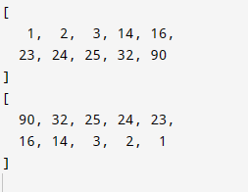  
  
**Задание 2**  
function pathExist(list, startNode, destinationNode) {

const visited = new Set();

function search(currentNode) {

if (currentNode === destinationNode) {

return true;

}

visited.add(currentNode);

const adjacentNodes = list[currentNode];

if (!adjacentNodes) {

return false;

}

for (let i = 0; i < adjacentNodes.length; i++) {

const nextNode = adjacentNodes[i];

if (!visited.has(nextNode)) {

if (search(nextNode)) {

return true;

}

}

}

return false;

}

return search(startNode);

}

var list = {A: ["B", "C"], B: ["D", "F"],C: ["K", "L"],D: ["M", "N"], E: ["P", "X"],F: ["Y", "Z"]};

console.log(pathExist(list, "A", "L")); // Вернет true

console.log(pathExist(list, "E", "F")); // Вернет false  
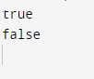  
**Задание 3**

function binarySearch(arr, target) {

let left = 0;

let right = arr.length - 1;

while (left <= right) {

const mid = Math.floor((left + right) / 2);

if (arr[mid] === target) {

return mid;

} else if (arr[mid] < target) {

left = mid + 1;

} else {

right = mid - 1;

}

}

return null;

}

const sortedArray = [0, 9, 13, 24,25,35,36,50, 54, 85, 100];

const targetValue = 50;

const position = binarySearch(sortedArray, targetValue);

console.log(position);



**Часть 2**

**Задание 1**

SELECT Restaurants.name

FROM Restaurants

JOIN Employees

ON Employees.restaurantsID=Restaurants.id

WHERE Employees.positionID=1

GROUP BY Restaurants.name

HAVING count(*)>2

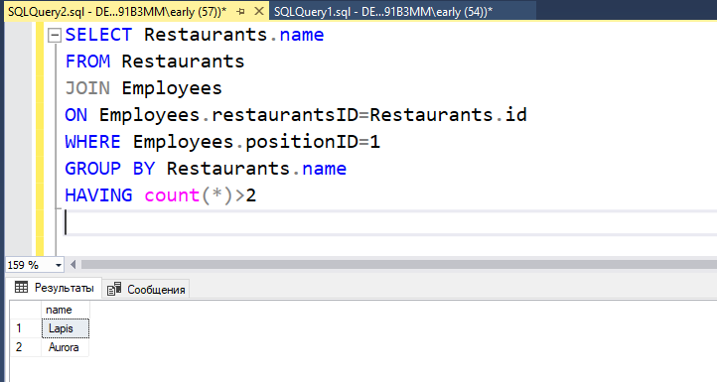  
**Задание 2**

INSERT INTO Employees(restaurantsID, firstname,lastname,phone,positionID)

VALUES(1303,'Andrey', 'Koblov','43434',4)

SELECT *

FROM Employees

WHERE restaurantsID=1303

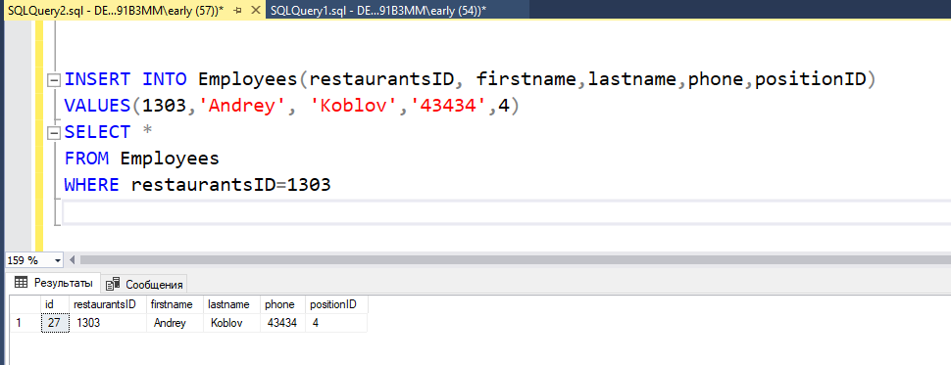

**Часть 3**

fetch("https://jsonplaceholder.typicode.com/posts", {

  method: 'POST',

  body: JSON.stringify({

    title: 'My Title',

    body: 'Lorem ipsum dolor sit amet',

    userId: 4

  }),

  headers: {

    'Content-Type': 'application/json'

  }

})

  .then(response => {

    if (response.ok) {

      return response.json();

    } else {

      throw new Error(`Ошибка HTTP: ${response.status}`);

    }

  })

  .then(jsonData => {

    console.log('Данные:', jsonData);

  })

  .catch(error => {

    console.error('Ошибка:', error);

  });

